Project Design Phase-II

Data Flow Diagram & User Stories

Date | 2 February 2026
Team ID | LTVIP2026TMIDS72673
Project Name | Gemini Historical Artifact Description
Maximum Marks | 4 Marks

Data Flow Diagrams:
A Data Flow Diagram (DFD) is a traditional visual representation of the information flows within a system. A neat and clear DFD can depict the right amount of the system requirement graphically. It shows how data enters and leaves the system, what changes the information, and where data is stored.
Example:
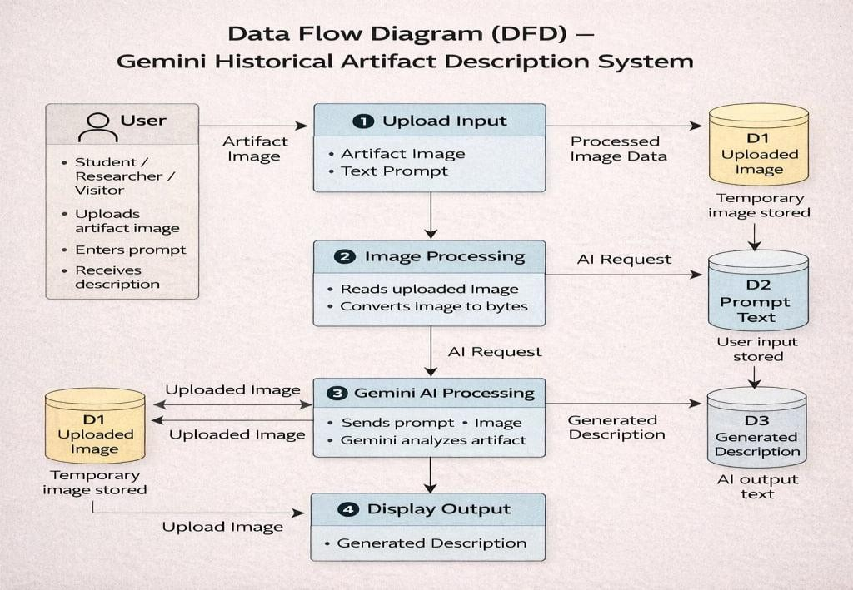

User Stories

User Type | Functional  Requirement (Epic) | User Story Number | User Story / Task | Acceptance criteria | Priority | Release
Customer (Web User – Student/Resear  cher) | Access Application | USN-1 | As a user, I can open the web application in my browser. | Application loads successfully and home page is visible | High | Sprint-1
Customer (Web  User) | Upload Image | USN-2 | As a user, I can upload an image of a historical  artifact. | Image preview is displayed  after upload | High | Sprint-1
Customer (Web  User) | Enter Prompt | USN-3 | As a user, I can type an artifact name or  description prompt. | Text input box accepts  user input | High | Sprint-1
Customer (Web  User) | Generate  Description | USN-4 | As a user, I can click “Generate Artifact  Description” button. | AI generates and shows  description on screen | High | Sprint-1
Customer (Web User) | View Result | USN-5 | As a user, I can read the detailed historical description generated by AI. | Description includes origin, period, material, and  significance | High | Sprint-1
Customer (Web  User) | Interesting Fact | USN-6 | As a user, I can see a historical fact while the  system is processing. | Historical fact message  appears during loading | Medium | Sprint-2
Customer (Web  user) | Error Handling | USN-7 | As a user, I get an error message if no image  is uploaded. | System shows “No file  uploaded” message | High | Sprint-1
Customer (Web  User) | API Configuration | USN-8 | As an admin, I can configure the Gemini API  key securely. | API key stored in .env and  system works | High | Sprint-1
Administrator | System  Maintenance | USN-9 | As an admin, I can monitor the application and  fix errors. | App runs without crash and  generates output | Medium | Sprint-1

User Type | Functional  Requirement (Epic) | User Story Number | User Story / Task | Acceptance criteria | Priority | Release
Customer Care  Executive | User Help | USN-10 | As an admin, I can monitor the application and  fix errors. | Users can successfully use  the system after guidance | Low | Sprint-1

